PIZZA SALES SQL QUERIES
A. KPI’s
1. Total Revenue:
select sum(total_price) as Total_Revenue from pizzasales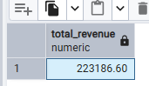

2. Average Order Value
select sum(total_price)/count(distinct order_id) as Average_order_id from pizzasales
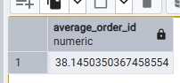

3. Total Pizzas Sold
select sum(quantity) as Total_pizza_sold from pizzasales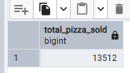

4. Total Orders
select count(distinct order_id) as Total_orders from pizzasales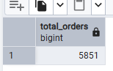
5. Average Pizzas Per Order
SELECT CAST(CAST(SUM(quantity) AS DECIMAL(10,2)) /
CAST(COUNT(DISTINCT order_id) AS DECIMAL(10,2)) AS DECIMAL(10,2))
AS Avg_Pizzas_per_order
FROM pizzasales
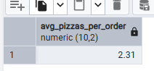

B. Daily Trend for Total Orders
SELECT ('{Sunday, Monday, Tuesday, Wednesday, Thursday, Friday, Saturday}'::text[])[EXTRACT(DOW FROM order_date) + 1] AS order_day, COUNT(DISTINCT order_id) AS total_orders
FROM pizzasales
GROUP BY EXTRACT(DOW FROM order_date)
Output:
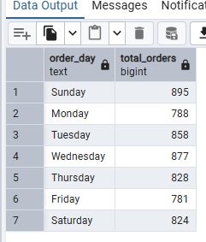
C. Monthly Trend for Orders
Monthly Trend for Orders
SELECT
('{January, February, March, April, May, June, July, August, September, October, November, December}'::text[])[EXTRACT(MONTH FROM order_date)] AS order_month, COUNT(DISTINCT order_id) AS total_orders
FROM pizzasales
GROUP BY EXTRACT(MONTH FROM order_date)
Output
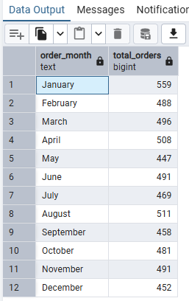

D. % of Sales by Pizza Category
SELECT pizza_category, CAST(SUM(total_price) AS DECIMAL(10,2)) as total_revenue,
CAST(SUM(total_price) * 100 / (SELECT SUM(total_price) from pizzasales) AS DECIMAL(10,2)) AS PCT
FROM pizzasales
GROUP BY pizza_category
Output
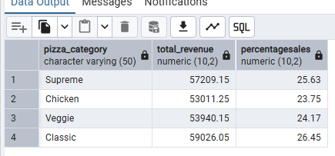
E. % of Sales by Pizza Size
SELECT pizza_size, CAST(SUM(total_price) AS DECIMAL(10,2)) as total_revenue,
CAST(SUM(total_price) * 100 / (SELECT SUM(total_price) from pizzasales) AS DECIMAL(10,2)) AS PCT
FROM pizzasales
GROUP BY pizza_size
ORDER BY pizza_size
Output
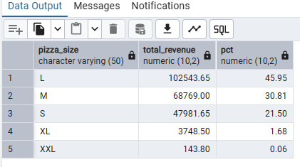
F. Total Pizzas Sold by Pizza Category
SELECT pizza_category, SUM(quantity) as Total_Quantity_Sold
FROM pizzasales
WHERE EXTRACT(MONTH FROM order_date)=2
GROUP BY pizza_category
ORDER BY Total_Quantity_Sold DESC
Output
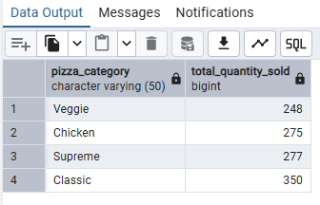
G. Top 5 Pizzas by Revenue
SELECT pizza_name, SUM(total_price) AS Total_Revenue
FROM pizzasales
GROUP BY pizza_name
ORDER BY Total_Revenue DESC
LIMIT 5
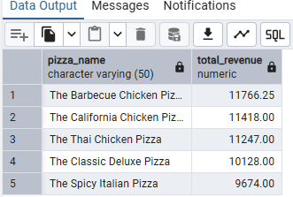

H. Bottom 5 Pizzas by Revenue
SELECT pizza_name, SUM(total_price) AS Total_Revenue
FROM pizzasales
GROUP BY pizza_name
ORDER BY Total_Revenue ASC
LIMIT 5
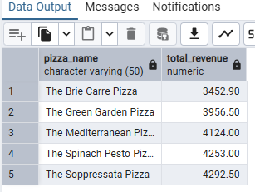

I. Top 5 Pizzas by Quantity
SELECT pizza_name, SUM(quantity) AS Total_Pizza_Sold
FROM pizzasales
GROUP BY pizza_name
ORDER BY Total_Pizza_Sold DESC
FETCH FIRST 5 ROWS ONLY
Output
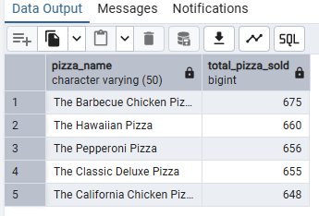
J. Bottom 5 Pizzas by Quantity
SELECT TOP 5 pizza_name, SUM(quantity) AS Total_Pizza_Sold
FROM pizzasales
GROUP BY pizza_name
ORDER BY Total_Pizza_Sold ASC
Output
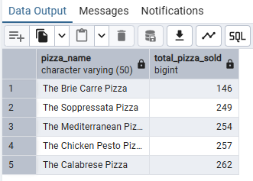
K. Top 5 Pizzas by Total Orders
SELECT Top 5 pizza_name, COUNT(DISTINCT order_id) AS Total_Orders
FROM pizzasales
GROUP BY pizza_name
ORDER BY Total_Orders DESC

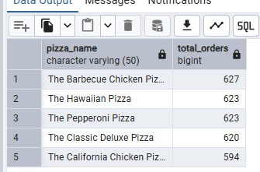

L. Bottom 5 Pizzas by Total Orders
SELECT Top 5 pizza_name, COUNT(DISTINCT order_id) AS Total_Orders
FROM pizzasales
GROUP BY pizza_name
ORDER BY Total_Orders ASC

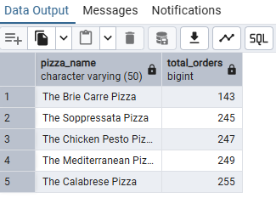
NOTE
If you want to apply the pizza_category or pizza_size filters to the above queries you can use WHERE clause. Follow some of below examples
SELECT Top 5 pizza_name, COUNT(DISTINCT order_id) AS Total_Orders
FROM pizzasales
WHERE pizza_category = 'Classic'
GROUP BY pizza_name
ORDER BY Total_Orders ASC

